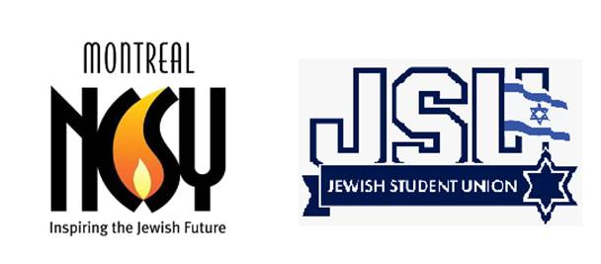

**Social Media & Marketing Fellowship**

*Full-Time 10 month Contract August 2025- June 2026*

*| Montreal-based | Hybrid |*

**Who We Are:**

NCSY and Torah High are Canada's premier national outreach and education organizations for Jewish teens, inspiring thousands of students through meaningful Jewish experiences, leadership development, and Jewish education.

**Position Summary:**

NCSY Canada is seeking a creative and highly motivated **Social Media and Marketing new grad for our Montreal-based fellowship opportunity.** The goal is to support the growth of our online presence in the Montreal region. The ideal candidate is a strong storyteller and visual creator with a deep understanding of social media trends, platforms, and youth engagement. This role is perfect for someone who thrives in a fast-paced, mission-driven environment and wants to make an impact.

**Key Responsibilities:**

* Assisted in developing and executing a dynamic social media strategy aligned with NCSY Canada’s brand and objectives.
* Support the planning, creation, and posting of daily content across multiple social media platforms (Instagram, Facebook, TikTok, etc.)
* Design visually engaging graphics, flyers, and digital assets using Canva and Adobe Creative Suite
* Film and edit short-form videos (e.g., Reels, TikToks, event highlights) using mobile and desktop tools
* Collaborate with regional teams to promote programs, events, and student impact stories
* Track analytics and engagement data to optimize content strategy
* Attend and cover NCSY events and programs in Montreal and other regions, occasionally during evenings or weekends; some travel required for Shabbatons and special programs
* Design, write, and schedule engaging newsletters and email campaigns using Constant Contact
* Collaborate with other staff to collect and organize content, announcements, and visuals for regular communications

**Technical Skills & Requirements:**

* Proficient with social media platforms and Meta Business Suite.
* Strong graphic design skills with tools like **Canva**, **Adobe Photoshop**, and **Illustrator**.
* Intermediate **video editing** skills using **Premiere Pro**, **CapCut**, or similar apps.
* Comfortably shooting quality video and photos with a mobile device.
* Familiarity with digital marketing metrics and content optimization.
* Experience using file-sharing and organization tools.
* Must own a **current smartphone** with a high-quality camera.
* Must have access to a **car** and be able to travel to NCSY events and programs regularly (mileage reimbursed).

**Preferred Qualifications:**

* Degree or diploma in Marketing, Digital Media, or a related field.
* Experience working with Jewish community organizations, or non-profits is a strong asset.

**Soft Skills:**

* Creative, resourceful, and full of fresh content ideas.
* Strong communicator – written, visual, and verbal.
* Organized and detail-oriented with strong time management skills.
* Team player with a positive, proactive attitude.
* Passionate about community building and youth engagement.
* Understanding and appreciation of Jewish values and culture.

**Salary and Benefits:**

The salary range for this position is $40,000.

The fellowship provides access to skill-building conferences and valuable hands-on work experience for a new graduate.

***Other benefits include:***

* Paid sick days
* Paid vacation days
* Paid Jewish and most Statutory holidays
* Short Fridays to accommodate for the Sabbath